**Manual Deploying of Oracle Service Bus App to SOACS**

After you export the resource configuration of the Oracle Service Bus project, you import the project configuration into Oracle SOA Suite Cloud Service:

1. **Open Oracle SOA Suite Cloud Service Console and click Menu Menu Icon  to select the service instance that you want to manage. Then, click Open Service Bus Console.**

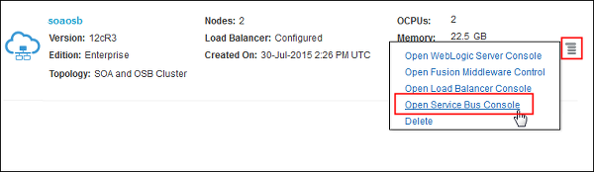

1. **In the Login page, enter your user ID and password and click Login.**

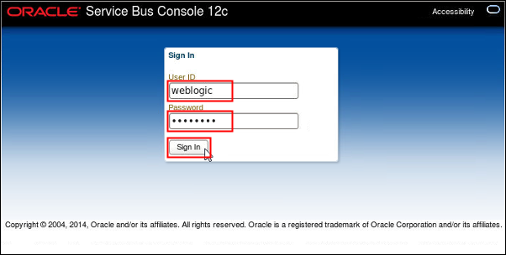

1. **On the Service Bus Console page, create a session by clicking Create.**

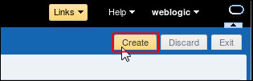

1. **On the Resources tab, click the Import Config Jar icon.**

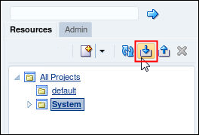

**The Import Config Jar page appears.**

1. **On the Import Config Jar page, click Browse.**

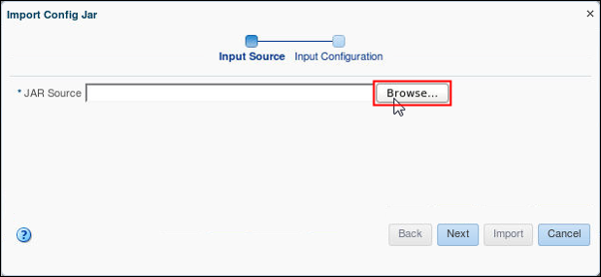

**The File Upload dialog box appears.**

1. **On the File Upload dialog box, go to the location where you saved the jar file and click Open.**

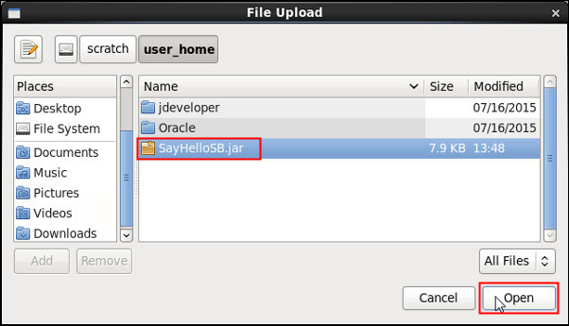

1. **On the Import Config Jar page, verify the location of the JAR source file and click Next.**

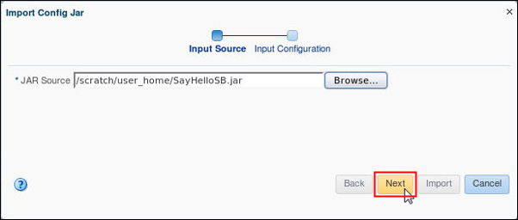

1. **On the Import Config Jar page, accept the default values and click Import.**

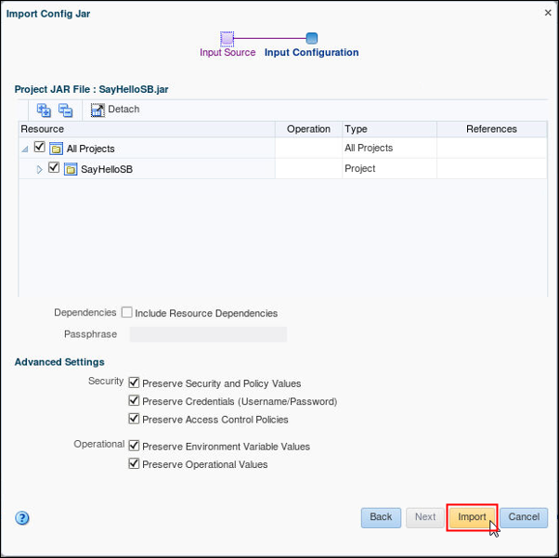

1. **On the Import Config Jar page, verify that the import completed successfully and click Close.**

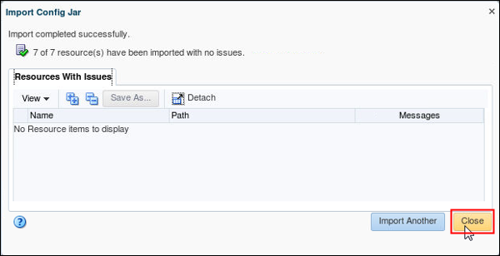

1. **On the Resources tab, expand the SayHelloSB project and click SayHelloService.**

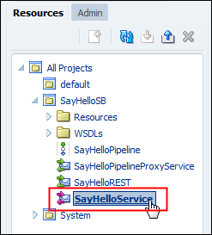

**The SayHelloService page appears on the Service Bus Overview Editor.**

1. **On the SayHelloService page, click the Transport tab and edit the endpoint URI. Replace localhost:7101 with the hostname and port number of the Oracle SOA Suite Cloud Service instance.**

**Note: Use the Oracle Traffic Director (OTD) host name, rather than the public IP address, if its metadata points to a service deployed on Oracle Weblogic Server in the same Oracle SOA Suite Cloud Service environment.**

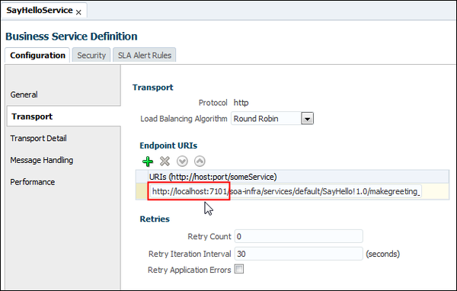

**Note: On the SayHello[1.0] test page from the Oracle Enterprise Manager application at the Oracle SOA Suite Cloud Service instance, you can verify the public IP address or hostname of your cloud instance along with the port number.**

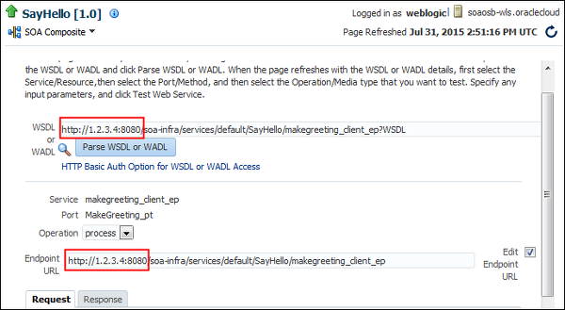

1. **On the Service Bus Console page, save the changes by clicking the Save Changes in All Tabs icon.**

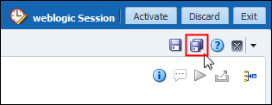[**Description of this image**](http://www.oracle.com/webfolder/technetwork/tutorials/obe/cloud/sscs/DeployingOSBApp_Cloud/files/t_03_12.txt)

1. **On the Service Bus Console page, click Activate.**

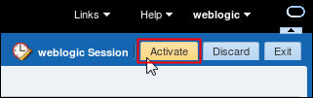[**Description of this image**](http://www.oracle.com/webfolder/technetwork/tutorials/obe/cloud/sscs/DeployingOSBApp_Cloud/files/t_03_13.txt)

**The Confirm Session Activation page appears.**

1. **On the Confirm Session Activation page, enter a description and click Activate.**

